The 3rd Annual BGSU
Nakamoto Peace Lecture
Gwynne Dyer
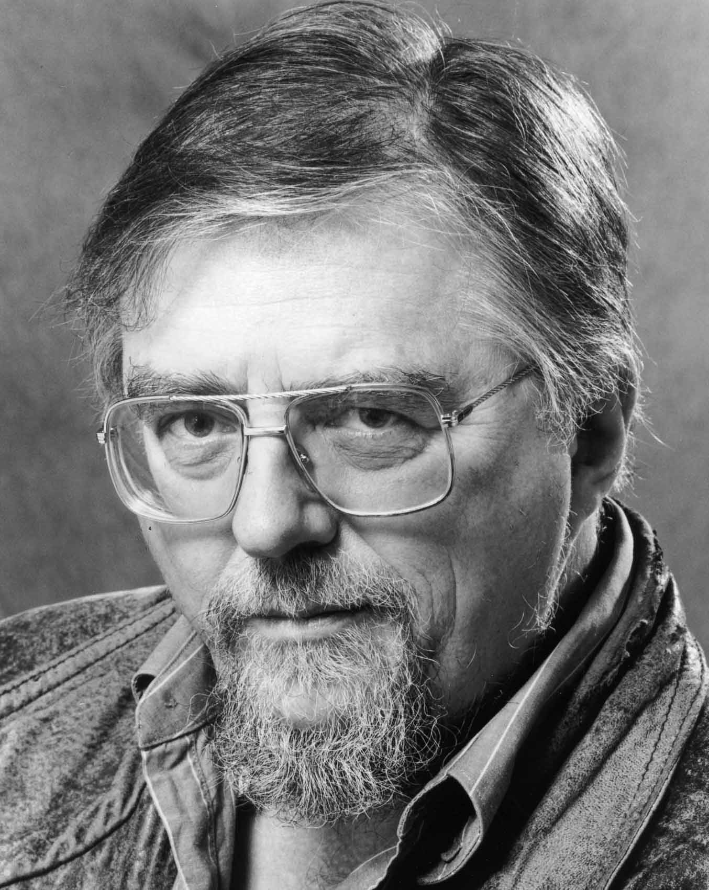
"The End of War?:
Nonviolence in the 21st Century."
7:30 P.M. Thursday, February 2, 2012
Bowen-Thompson Student Union Theater
Free and open to the public
One of the world’s great geopolitical analysts, Gwynne Dyer has worked as a freelance journalist, columnist, filmmaker, and lecturer on international affairs for over 30 years. His twice-weekly column on international affairs appears in over 40 countries in a variety of newspapers including the Toledo Blade. His radio and TV documentaries on the subjects of ranging from war to climate change and emerging global culture have aired around the world. He has served in three navies, and holds a Ph.D in Military and Middle Eastern History from the University of London. His recent books analyze military and political issues and include War (2004), Future: Tense (2004), The Mess They Made (2007), and Climate Wars (revised edition 2010).

This lecture is made possible by a generous donation from Ms. Hiroko Nakamoto, a BGSU alum. It is co-sponsored by the International Relations Organization, the Department of Political Science, and the BGSU Peace and Conflict Studies program.

Ms. Nakamoto is in the process of constructing a peace memorial in her hometown of Hiroshima, Japan. Located near the railway station, her” Gateway to Peace” project promotes peace and seeks to educate young people about the lessons of Hiroshima, which are fast being forgotten. Ms. Nakamoto seeks to inspire young people to build a more peaceful world, so that no one will ever relive what she experienced as a young girl on August 6, 1945. You can learn more about this project at http://hiroshimagatewaytopeace.org.

For additional information, please contact Marc Simon (372-7386; msimon@bgsu.edu).

